## **Multitasking**

Multitasking is a process of executing multiple tasks simultaneously. We use multitasking to utilize the CPU. Multitasking can be achieved in two ways:

* Process-based Multitasking (Multiprocessing)
* Thread-based Multitasking (Multithreading)

### **1) Process-based Multitasking (Multiprocessing)**

* Each process has an address in memory. In other words, each process allocates a separate memory area.
* A process is heavyweight.
* Cost of communication between the process is high.
* Switching from one process to another requires some time for saving and loading [registers](https://www.javatpoint.com/register-memory), memory maps, updating lists, etc.

### **2) Thread-based Multitasking (Multithreading)**

* Threads share the same address space.
* A thread is lightweight.
* Cost of communication between the thread is low

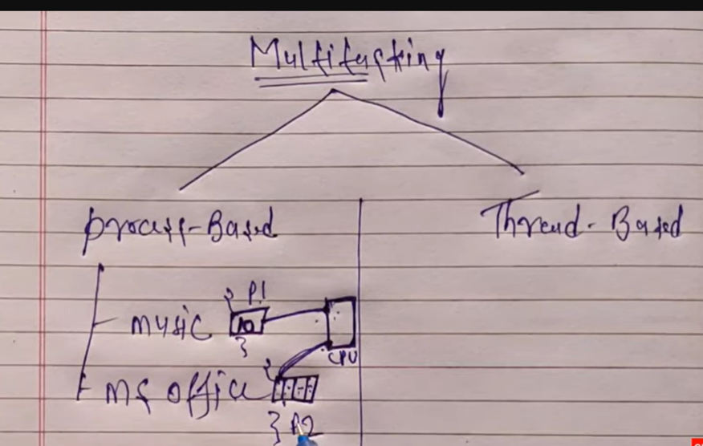

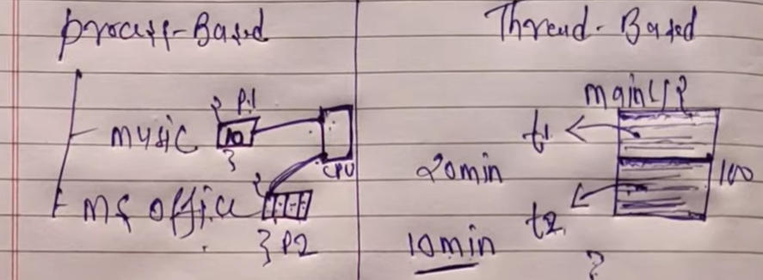

**Multithreading in Java**

**Multithreading in**[**Java**](https://www.javatpoint.com/java-tutorial) is a process of executing multiple threads simultaneously.

Multithreading is a Java feature that allows concurrent execution of two or more parts of a program for maximum utilization of CPU. Each part of such program is called a thread. So, threads are light-weight processes within a process.

**A thread is a lightweight sub-process, the smallest unit of processing. Multiprocessing and multithreading, both are used to achieve multitasking.**

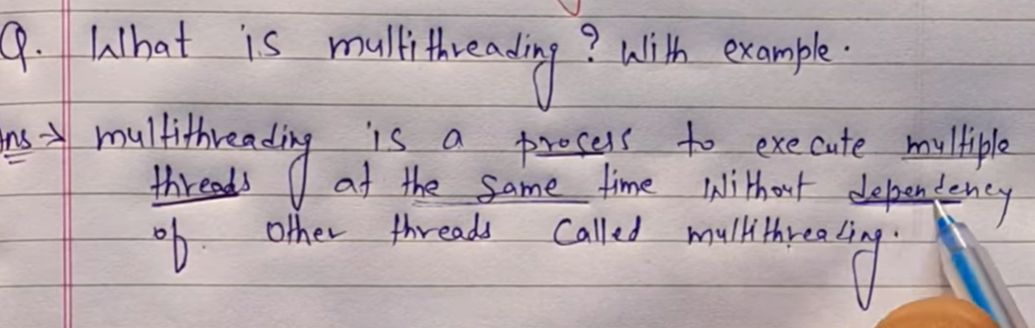

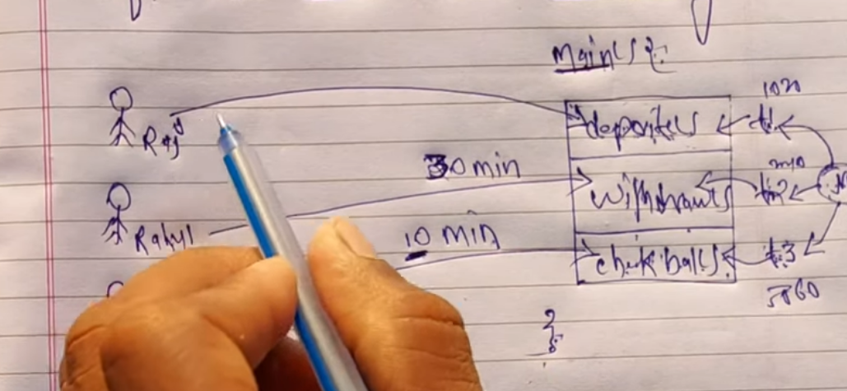

**JVM store thread in different memory location….**

So if any one thread throw an exception then other have no affect on it.

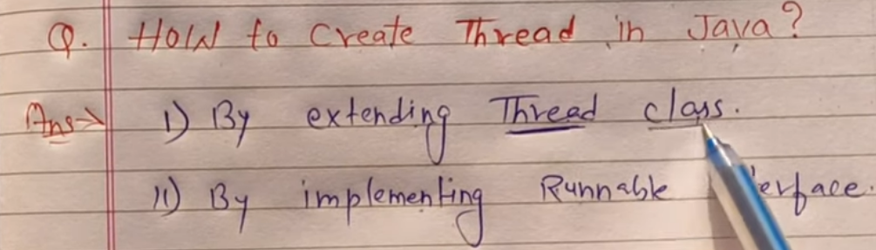

### **Advantages of Java Multithreading**

1) It **doesn't block the user** because threads are independent and you can perform multiple operations at the same time.

2) You **can perform many operations together, so it saves time**.

3) Threads are **independent**, so it doesn't affect other threads if an exception occurs in a single thread.

Threads can be created by using two mechanisms :

1. **Extending the Thread class**
2. **Implementing the Runnable Interface**
3. **Thread creation by extending the Thread class**

We create a class that extends the **java.lang.Thread** class. This class overrides the run() method available in the Thread class. A thread begins its life inside run() method. We create an object of our new class and call start() method to start the execution of a thread. Start() invokes the run() method on the Thread object.

In java program there is one thread is always available which is ***main thread.***

***JVM not execute code directly it execute with the help of thread.***

JVM call this **main thread**. The task of this main thread is to complete the execution of main method and whatever we create thread -> create object of it (by programmer) and complete their task.

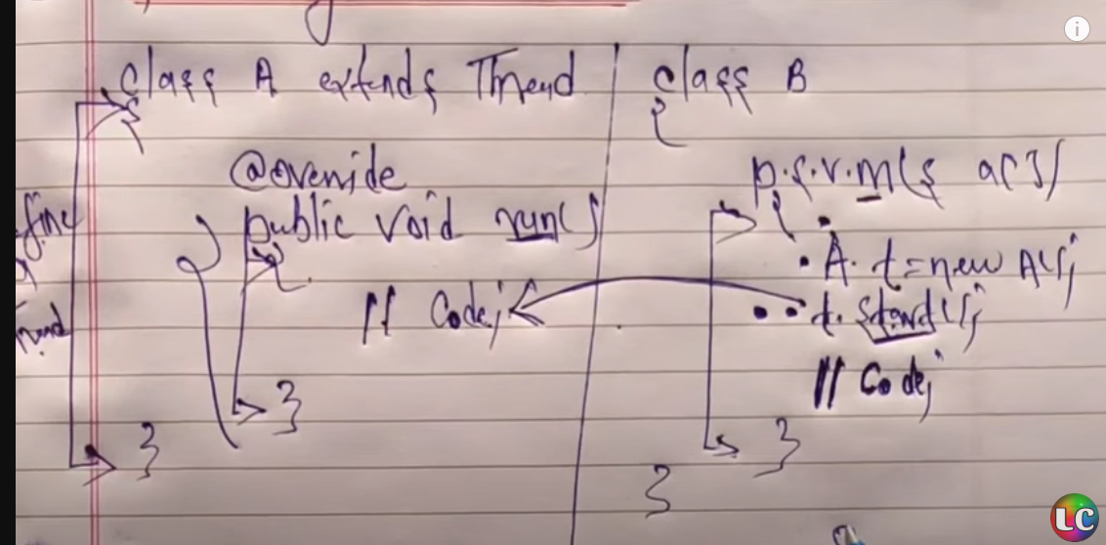

For this example we create class A which task is done by thread t.

Using t.start() the task of class A will done by thread t and other code will executed by main thread.

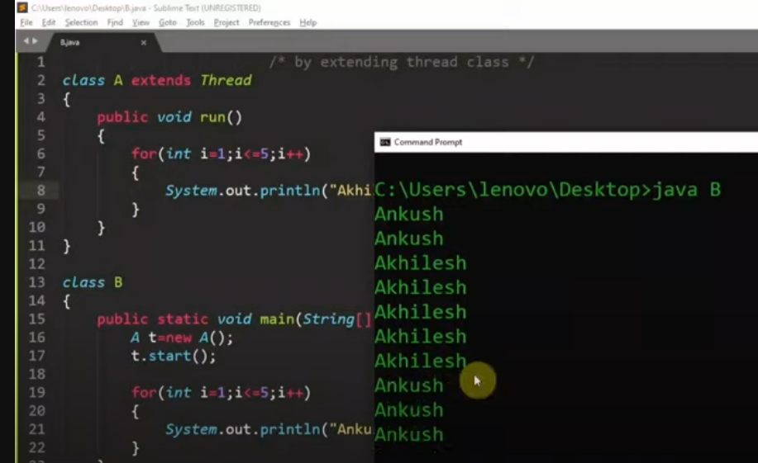

Both **MAIN** thread and **T** thread work simulteniously.

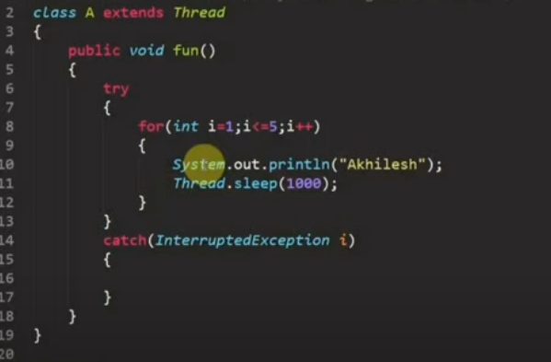

If we not use run method then it will not consider as a thread instead of this it will consider as simple method then there is only one thread in program so base on declaration it will be executed.

1. **Thread creation by implementing the Runnable Interface**  
   We create a new class which implements java.lang.Runnable interface and override run() method. Then we instantiate a Thread object and call start() method on this object.

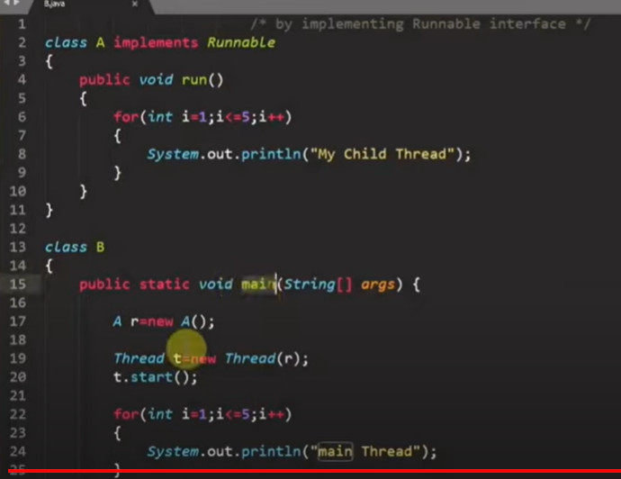

For this program Runnable Interface have only one metod which is run().

If we want to start thread then we have to create object of Thread class.

*Why we need to create obj of thread* ? **bcz to start the thread only thread class has method with we can start the thread not in runnable interface.**

**Thread Class vs Runnable Interface (must read….)**

1. **If we extend the Thread class, our class cannot extend any other class because Java doesn’t support multiple inheritance. But, if we implement the Runnable interface, our class can still extend other base classes.**
2. We can achieve basic functionality of a thread by extending Thread class because it provides some inbuilt methods like yield(), interrupt() etc. that are not available in Runnable interface.
3. Using runnable will give you an object that can be shared amongst multiple threads.

**Thread schedular**

**It’s a part of processor which execute multiple threads on a single process** **randomly**.

Its work like which thread executed when….

A component of Java that decides which thread to run or execute and which thread to wait is called a **thread scheduler in Java**. In Java, a thread is only chosen by a thread scheduler if it is in the runnable state. However, if there is more than one thread in the runnable state, it is up to the thread scheduler to pick one of the threads and ignore the other ones. There are some criteria that decide which thread will execute first. There are two factors for scheduling a thread i.e. **Priority** and **Time of arrival**.

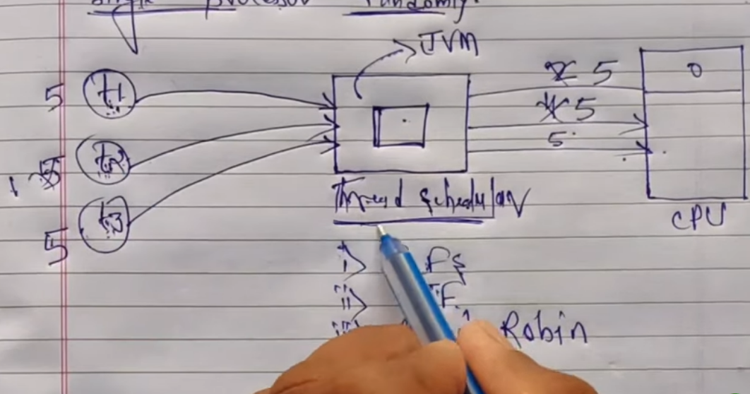

# Life cycle of a Thread

# In Java, a thread always exists in any one of the following states

1. New
2. Active
3. Blocked / Waiting
4. Timed Waiting
5. Terminated

**New:** Whenever a new thread is created, it is always in the new state. For a thread in the new state, the code has not been run yet and thus has not begun its execution.

**Active:** When a thread invokes the start() method, it moves from the new state to the active state. The active state contains two states within it: one is **runnable**, and the other is **running**.

* **Runnable:** A thread, that is ready to run is then moved to the runnable state. In the runnable state, the thread may be running or may be ready to run at any given instant of time. It is the duty of the thread scheduler to provide the thread time to run, i.e., moving the thread the running state.  
  A program implementing multithreading acquires a fixed slice of time to each individual thread. Each and every thread runs for a short span of time and when that allocated time slice is over, the thread voluntarily gives up the CPU to the other thread, so that the other threads can also run for their slice of time. Whenever such a scenario occurs, all those threads that are willing to run, waiting for their turn to run, lie in the runnable state. In the runnable state, there is a queue where the threads lie.
* **Running:** When the thread gets the CPU, it moves from the runnable to the running state. Generally, the most common change in the state of a thread is from runnable to running and again back to runnable.

**Blocked or Waiting:** Whenever a thread is inactive for a span of time (not permanently) then, either the thread is in the blocked state or is in the waiting state.

**Terminated:** A thread reaches the termination state because of the following reasons:

* When a thread has finished its job, then it exists or terminates normally.
* **Abnormal termination:** It occurs when some unusual events such as an unhandled exception or segmentation fault.

A terminated thread means the thread is no more in the system. In other words, the thread is dead, and there is no way one can respawn (active after kill) the dead thread.

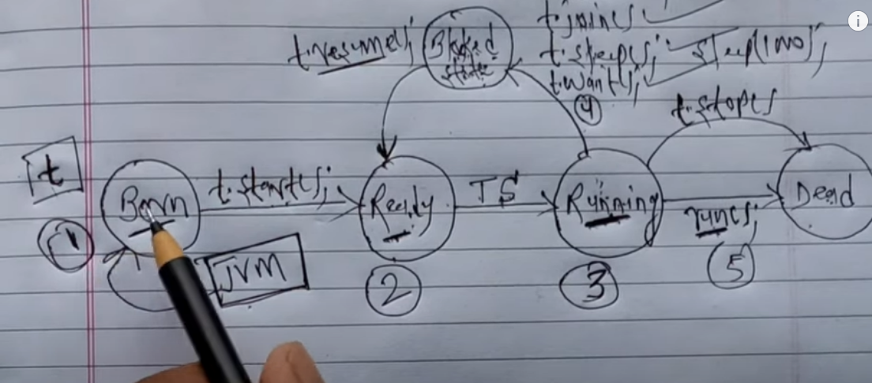

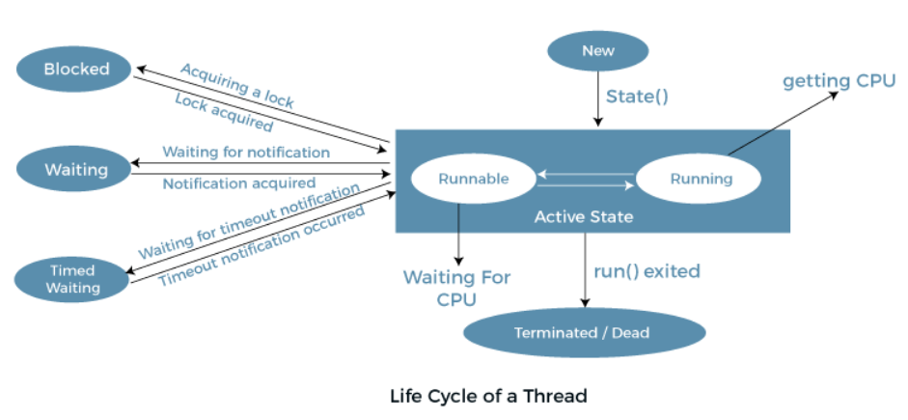

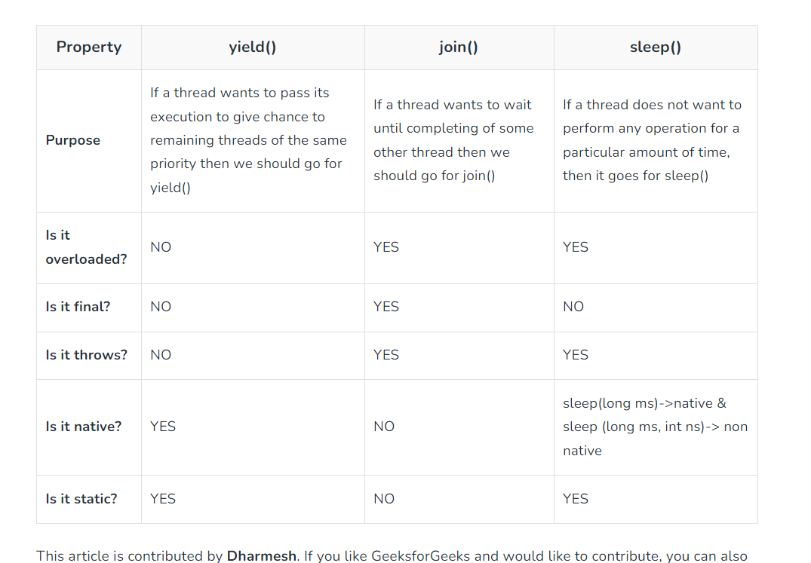

### **1. yield() Method**

Suppose there are three threads t1, t2, and t3. Thread t1 gets the processor and starts its execution and thread t2 and t3 are in Ready/Runnable state. The completion time for thread t1 is 5 hours and the completion time for t2 is 5 minutes. Since t1 will complete its execution after 5 hours, t2 has to wait for 5 hours to just finish 5 minutes job. In such scenarios where one thread is taking too much time to complete its execution, we need a way to prevent the execution of a thread in between if something important is pending. yield() helps us in doing so.

The **yield()**basically means that the thread is not doing anything particularly important and if any other threads or processes need to be run, they should run. Otherwise, the current thread will continue to run.

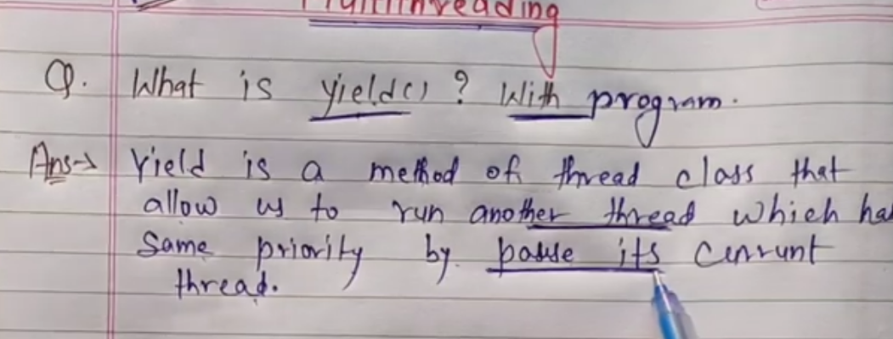

**Use of yield method:**

* Whenever a thread calls**java.lang.Thread.*yield****method gives hint to the thread scheduler that it is ready to pause its execution. The thread scheduler is free to ignore this hint.*
* **If any thread executes the yield method, the thread scheduler checks if there is any** **thread with the same or high priority as this thread. If the processor finds any thread with higher or same priority then it will move the current thread to Ready/Runnable state and give the processor to another thread and if not – the current thread will keep executing.**
* Once a thread has executed the yield method and there are many threads with the same priority is waiting for the processor, then we can’t specify which thread will get the execution chance first.
* **The thread which executes the yield method will enter in the Runnable state from Running state**.
* Once a thread pauses its execution, we can’t specify when it will get a chance again it depends on the thread scheduler.
* The underlying platform must provide support for preemptive scheduling if we are using the yield method.

### **2. sleep() Method**

**This method causes the currently executing thread to sleep for the specified number of milliseconds**, subject to the precision and accuracy of system timers and schedulers.

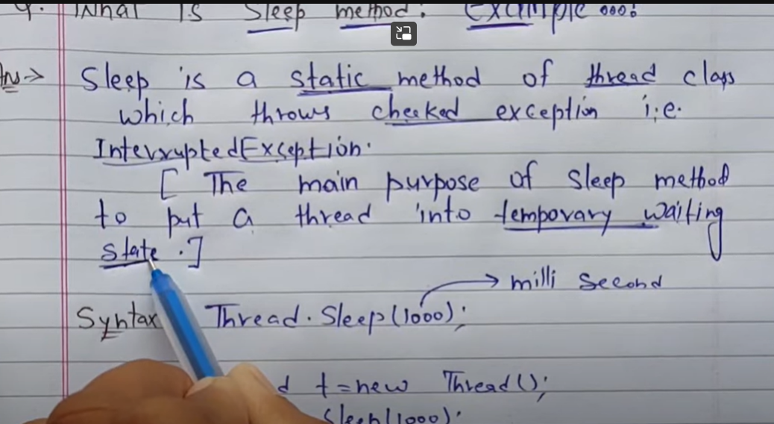

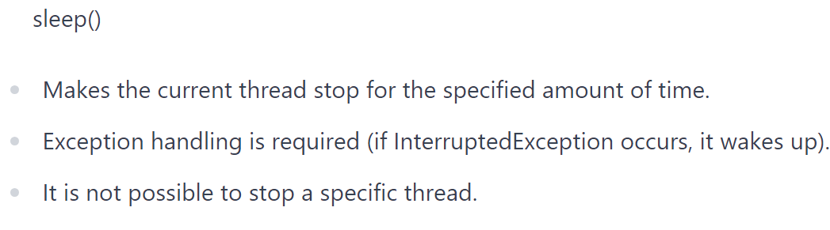

### **3. join() Method**

**The join() method of a Thread instance is used to join the start of a thread’s execution to the end of another thread’s execution such that a thread does not start running until another thread ends. If join() is called on a Thread instance, the currently running thread will block until the Thread instance has finished executing. The join() method waits at most this many milliseconds for this thread to die. A timeout of 0 means to wait forever**

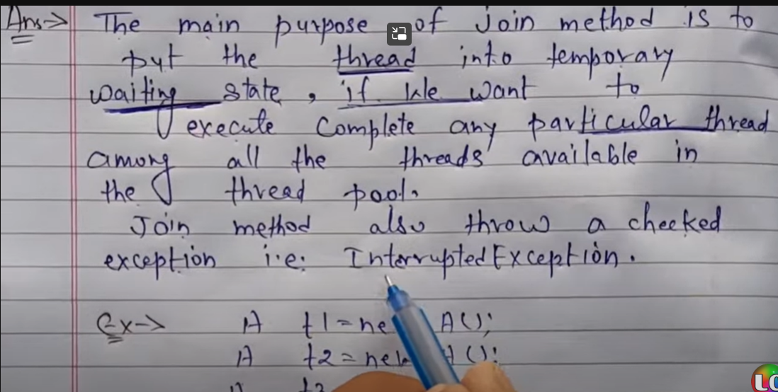

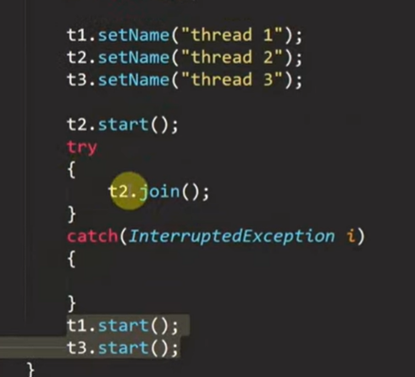 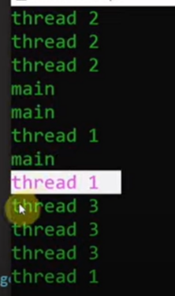

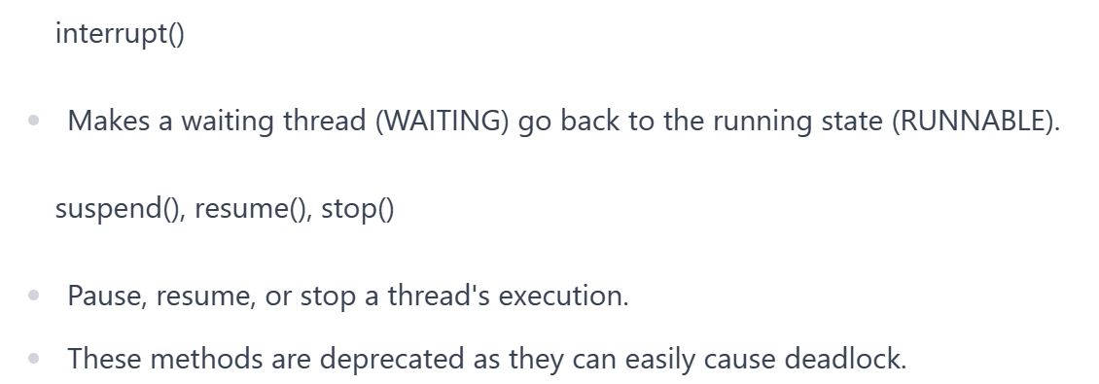

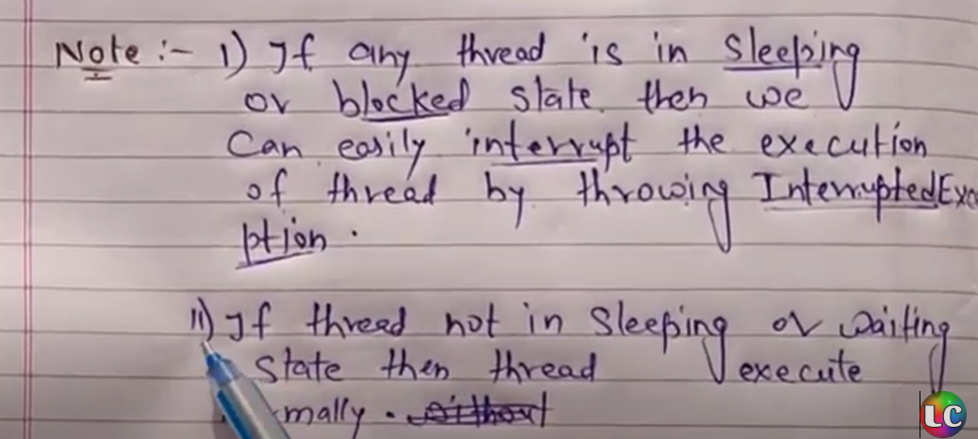

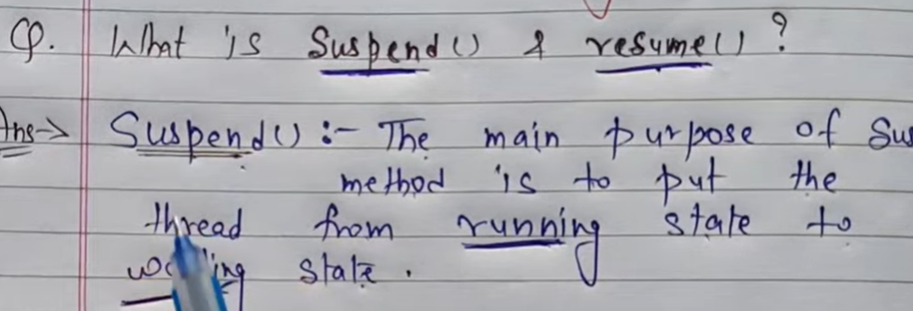



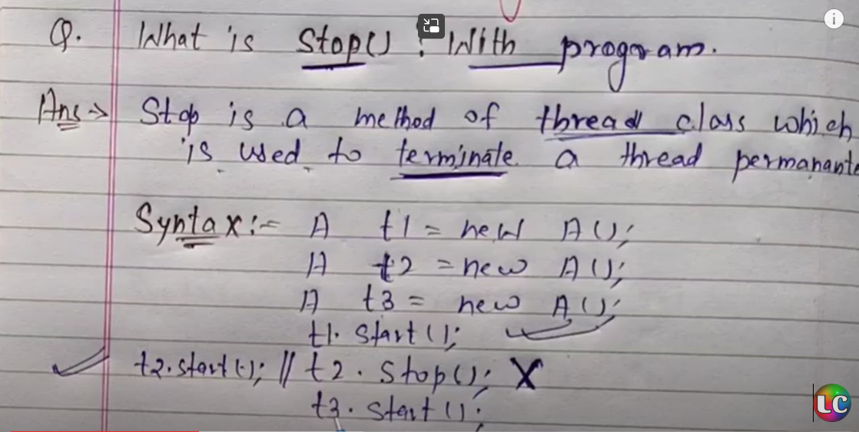

**Thread synchronization**

* In a multi-threaded process, one thread's work can affect another thread.
* Synchronization is necessary to prevent interference by other threads with ongoing work.

"Thread synchronization - preventing other threads from interfering with the work of a thread in progress."

* To synchronize, set the characters that should not be interfered with as "critical sections."
* Only one thread with a lock (one lock per object) can enter the critical section.

**wait() and notify()**

* Use wait() (waiting) and notify() (informing) to improve synchronization efficiency.
* Defined in the Object class and can only be used within a synchronization block.

1. wait() - Releases the object's lock and puts the thread into the waiting pool for that object.
2. notify() - Wakes up one of the waiting threads in the waiting pool.
3. notifyAll() - Wakes up all waiting threads in the waiting pool.

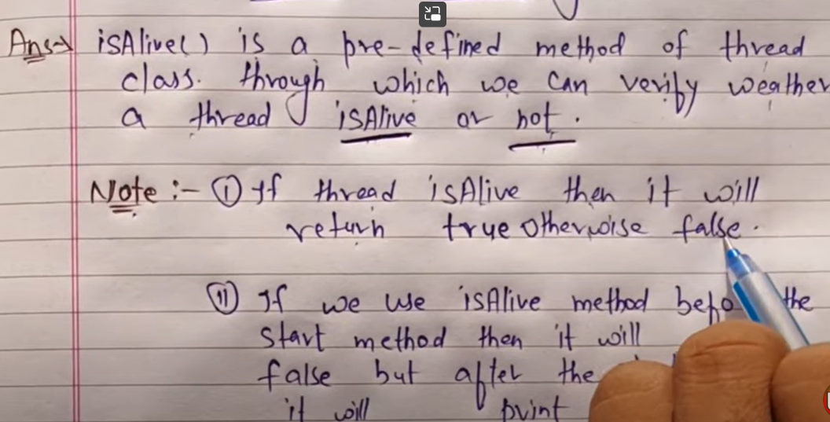



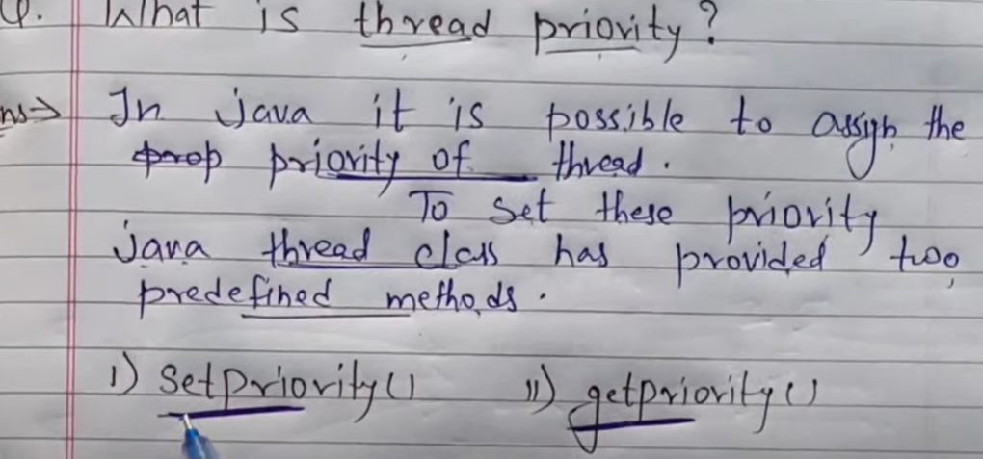

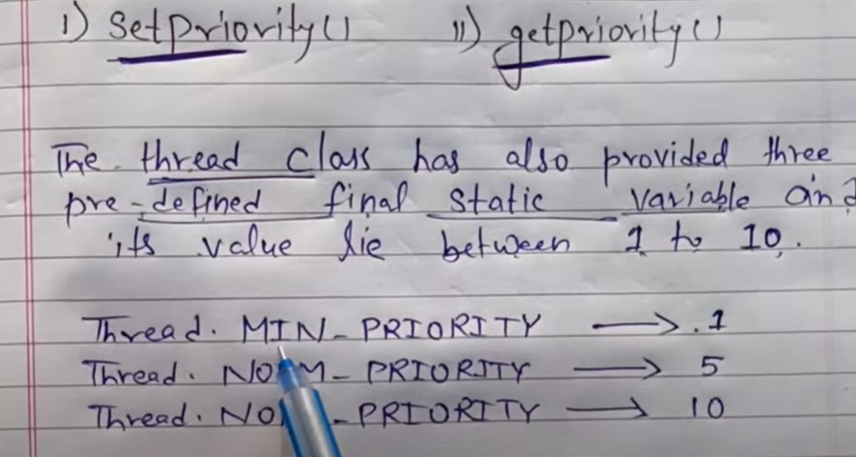

**Thread.MAX_PRIORITY** 🡪 10

**By default jvm set priority of thread by 5**

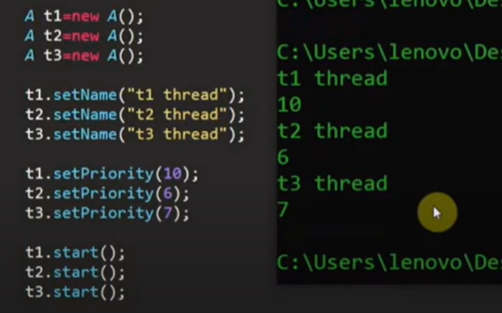

# Synchronization in Java

**Synchronization in Java is the capability to control the access of multiple threads to any shared resource.**

**Java Synchronization is better option where we want to allow only one thread to access the shared resource.**

**It is use when there is only one resources and multiple thread working on it.**

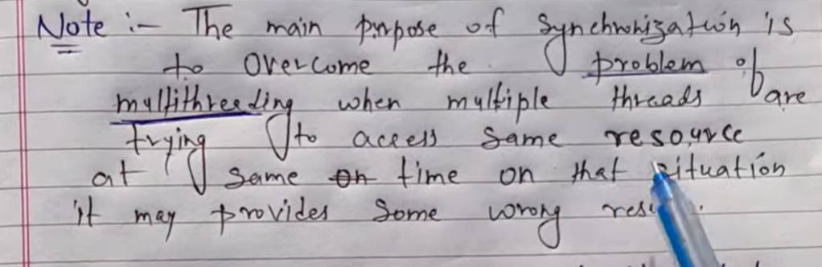

### **Types of Synchronization**

There are two types of synchronization

1. **Process Synchronization**
2. **Thread Synchronization**

### **Thread Synchronization**

There are two types of thread synchronization mutual exclusive and inter-thread communication.

1. Mutual Exclusive
   1. Synchronized method.
   2. Synchronized block.
   3. Static synchronization.
2. Cooperation (Inter-thread communication in java)

**Problem** : Suppose there are 3 person sharing same bank account in join which have 5K in account and they all are going to withdraw the money at same time and try to withdraw money so problem is the all are able to 5k money from bank acc. Without synchronization because multithreading allow to share same resources to every one at the same time. But we need to prevent this problem another 2 cant able to withdraw the money. Which we can achived using synchronization.

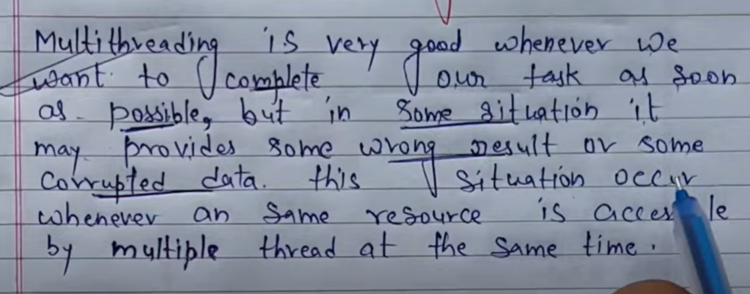

**Synchronization allowed only one thread to access one resource at a time to prevent such problem**

**In synchronized area only one thread can enter at a time.**

**Method Level synchronization**

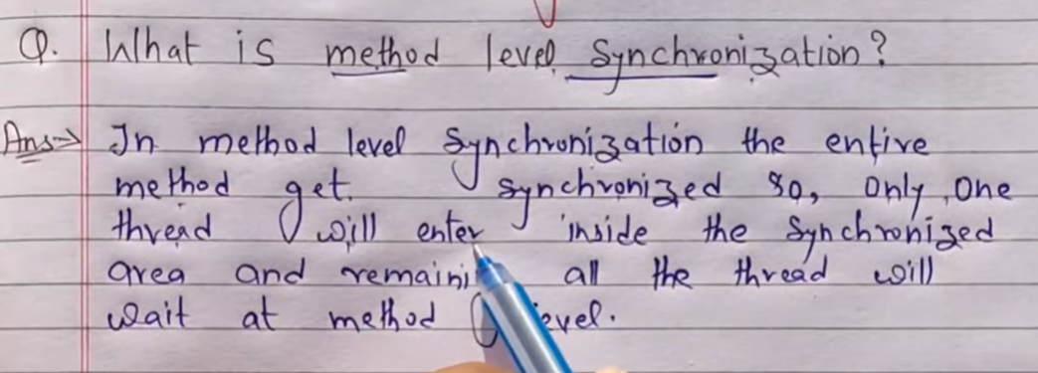

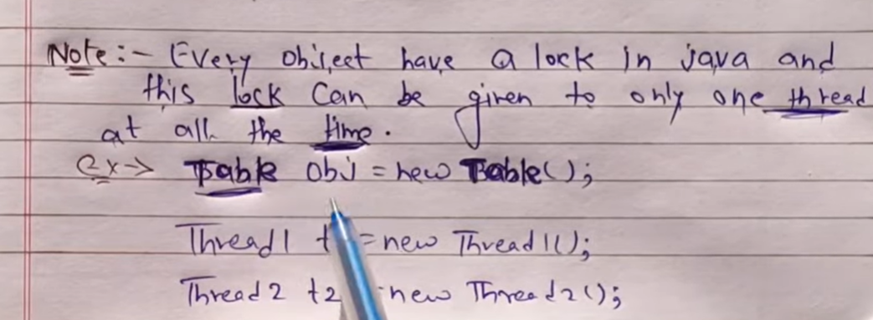

**Slow in execution compare to block level.**

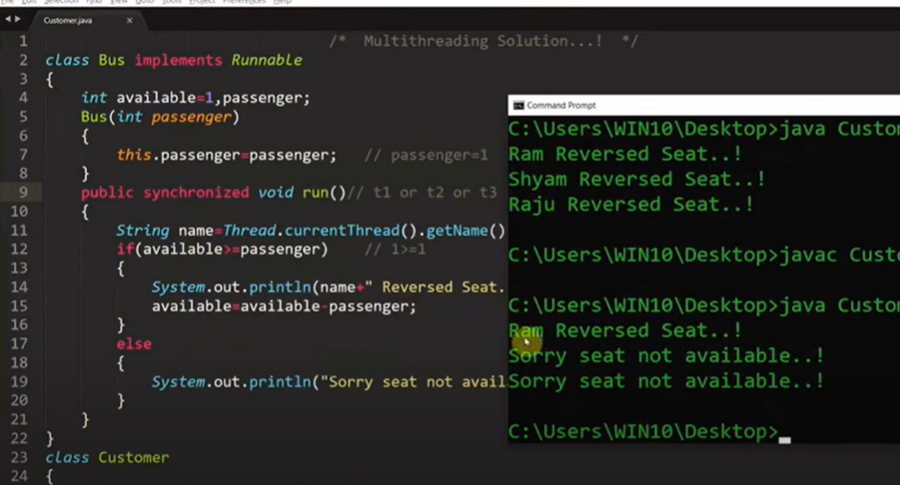 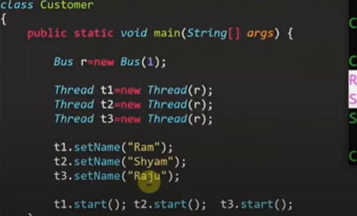

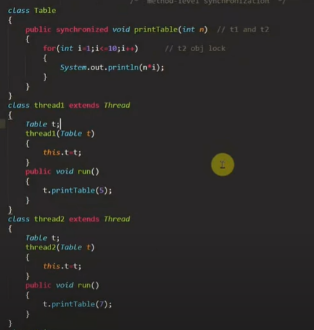

**Block Level**

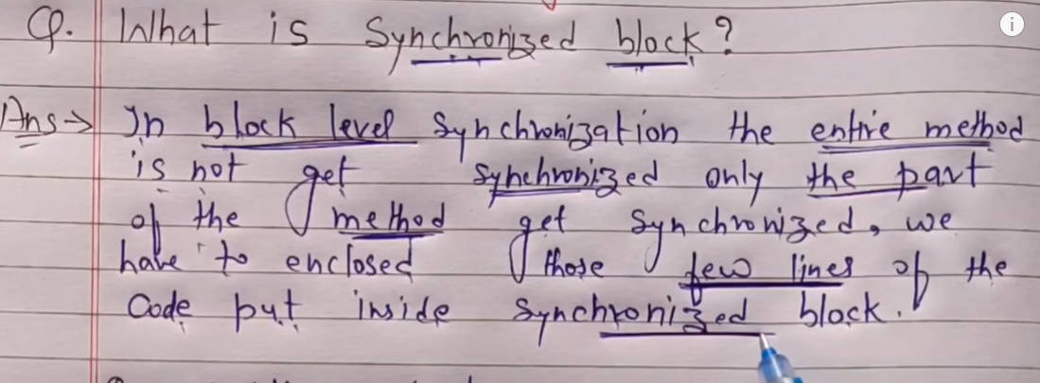 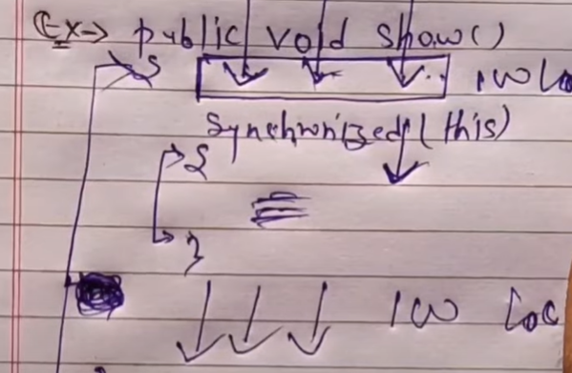

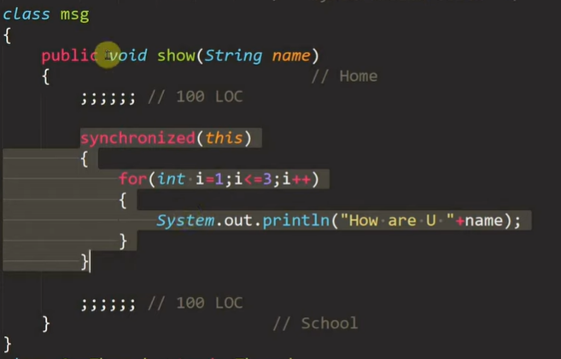

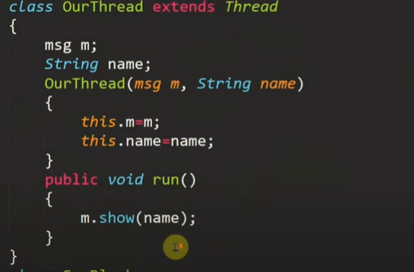 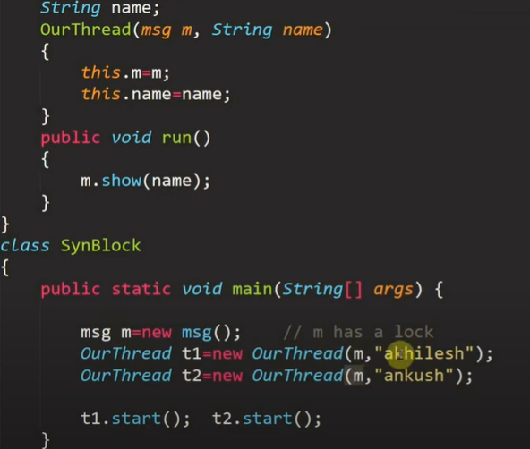

**Synchronization Problem :**

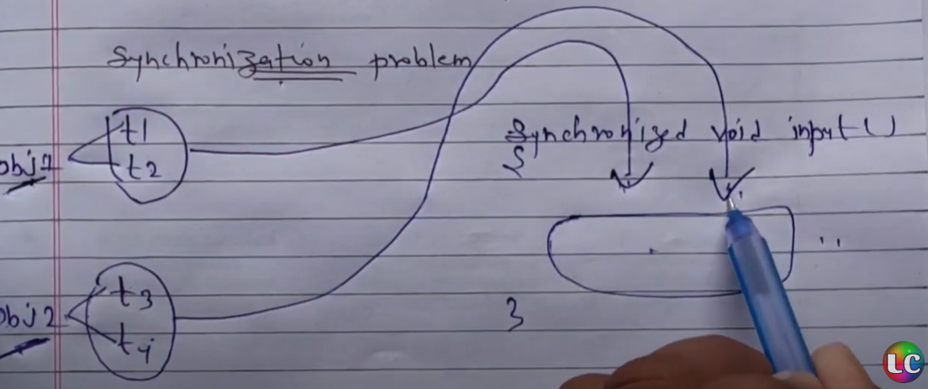

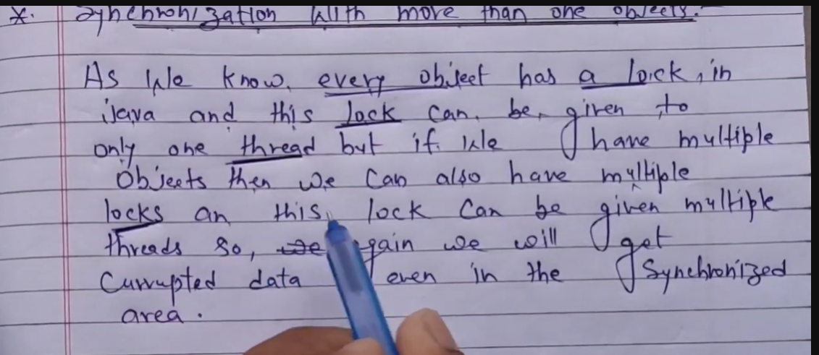

# Static Synchronization

If you make any static method as synchronized, the lock will be on the class not on object

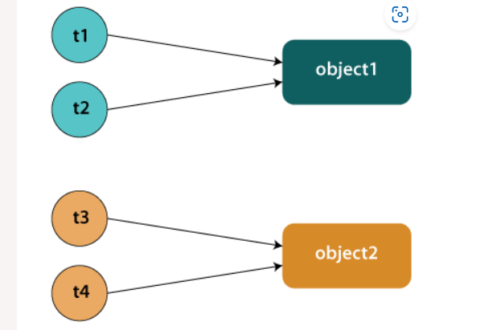

### **Problem without synchronization**

Suppose there are two objects of a shared class (e.g. Table) named object1 and object2. In case of synchronized method and synchronized block there cannot be interference between t1 and t2 or t3 and t4 because t1 and t2 both refers to a common object that have a single lock. But there can be interference between t1 and t3 or t2 and t4 because t1 acquires another lock and t3 acquires another lock. We don't want interference between t1 and t3 or t2 and t4. Static synchronization solves this problem.

Solution :

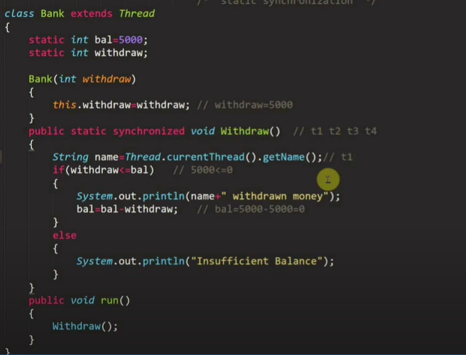

**Now using static syn. Lock is applied on class instead of obj. so if class has only one lock then only one thread can allowed to use resources.**